Jenkins users creation document

Step 1. Go to Manage Jenkins -> Manage Users -> Create user -> Set Credentials (username, password etc).

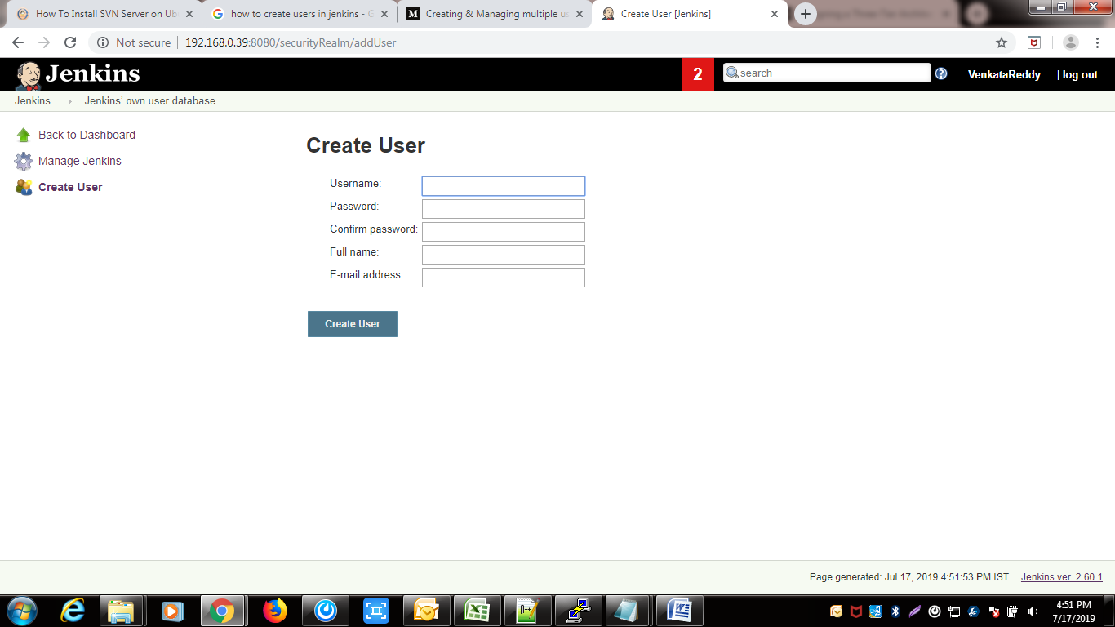

Step 2. Create and manage user roles:-

Go to manage Jenkins -->configure global security -->matrix based security.

In that we have to give the permissions to every user.

Note: Make sure admin have all permissions.

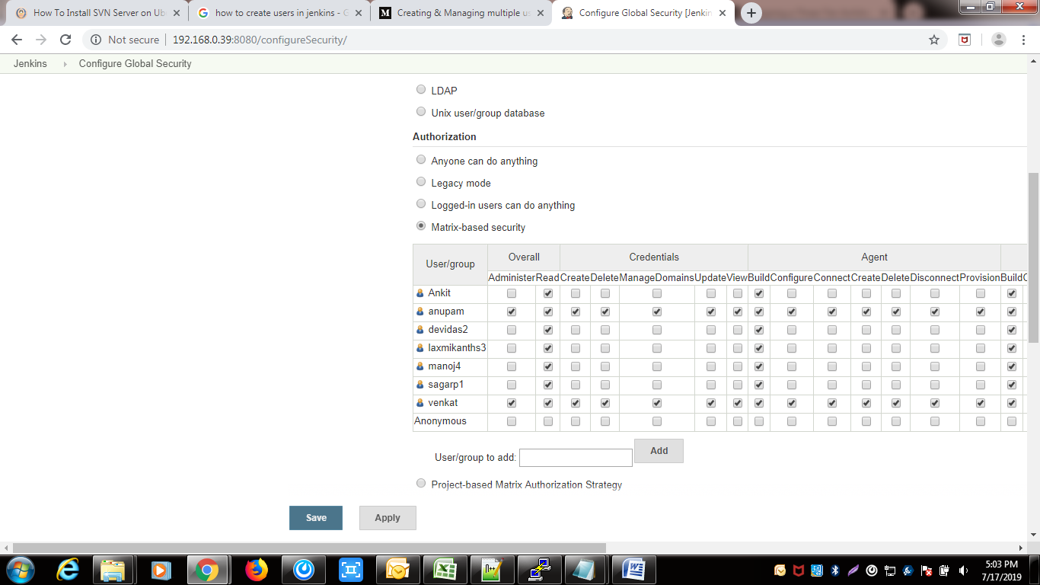

Then click on Apply and save.